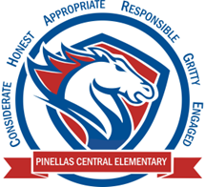

**Pinellas Central Elementary School**

**3rd Grade School Supply List 2024-2025**

**Student Items (for individual student use)**

* 1 pair of ear buds or headphones (necessary for computer lab work)
* backpack
* 4 three prong plastic 2 pocket folders (red, yellow, green, blue)
* 3 composition notebooks
* 4 packs of sticky notes (standard size)
* pencils (standard yellow)
* colored pencils
* glue sticks

**Supplemental Classroom Items-Donations Welcome**

* hand sanitizer
* disinfectant wipes
* tissues
* plastic zipper bags (all sizes but mostly gallon sized)
* wide ruled paper
* dry erase markers (black ink only)